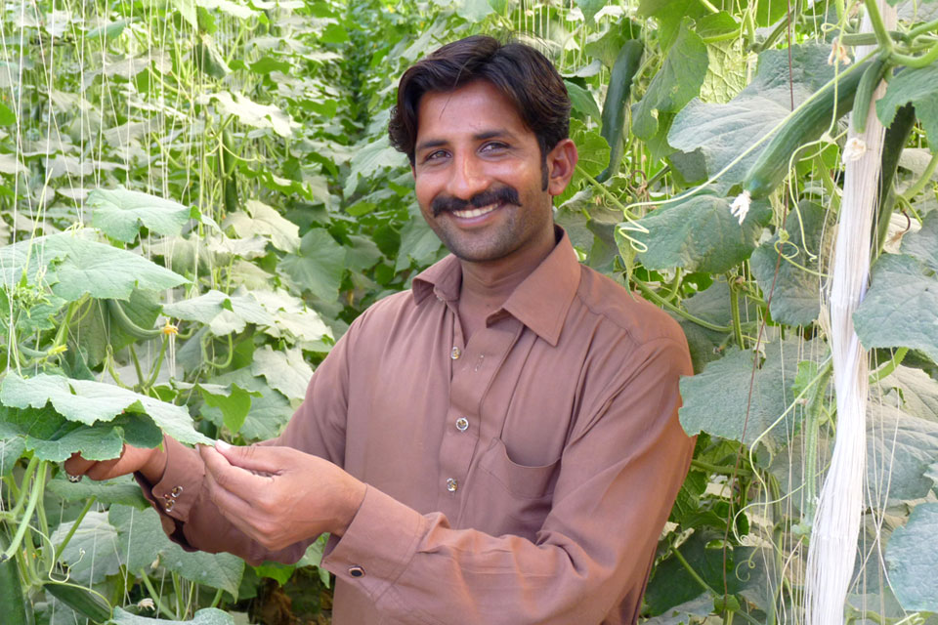

**EHSAN ULLAH BARYAR**

**(31 years)**

**Farmer of Onion, Cucumber & Okra**

**Land Ownership: 21 acres**

**Muridke, Lahore**

Ehsna Ullah Baryar has chosen the agriculture and farming as formal career due to his deep association with his land of his forefathers. Therefore, he decided to become part of value chain of F2P and work with modern farming technologies and practices. He is a main grower of Onion, Cucumber and Okra and ship it directly to F2P warehouses as per standard SOPs and practices.

You can also reach Ehsan Ullah Baryar directly at whatsapp: 0345 – 8550743